**ISM 6155 Project User Guide – Group 7**

# Introduction

The aim of the project involves the analysis of non-school district taxable property values on commercial corridors in the CRA of St. Petersburg, FL since 2018 with a focus on understanding annual changes and overall trends. The analysis depicts the insights into how these values of all corridors changed over the designated period of time, helping anyone intending on building, renting, purchase, or investing in property located in St. Petersburg. Additionally (and most importantly for this project), by visualizing the information pertaining to taxable values of properties while restructuring or updating infrastructure in these areas, the city will use a well-informed decision analysis process for any future activities. The project's goal is to examine the efficiency of the city of St. Petersburg's investments (both public and private) in various corridors of interest and to learn which investments have been the most successful so that the city might make similar investments in the future.

# Methodology

**Data Source**

The data sets used are the PAO Dept of review data from the year 2018 to 2022 for the city of St. Petersburg, provided to us by a direct source to the data. These data sets were in Excel format and part of a larger shared Box site folder with other datasets, and we were given both a document with an explanation of each column and the relevant column names needed for the analysis. The link to the data is listed below:

<https://usf.app.box.com/s/9j4jocx5p7w331f5aqlyuwvbc8r8vfvr>

**Data Cleaning**

The data was cleaned via Tableau Prep Builder. We started with approximately 107,000 rows. Using the software, we omitted the null values and columns with irrelevant data. Only the relevant data within the CRA boundary and in the corridors of interest (those within ½ mile of the corridor were excluded) are considered for better clarity. The following calculated field was used to find whether a row was within our boundaries set for being relevant to the problems being solved:

IF ISNULL ([16th St Corridor]) AND ISNULL ([18Th Ave S Corridor]) AND ISNULL ([22nd St S Corridor]) AND ISNULL ([34th St Corridor]) AND ISNULL ([49th St Corridor]) AND ISNULL ([5thAve Corridor]) AND ISNULL ([Dr MLK Jr St Corridor]) AND ISNULL ([Central Ave Corridor]) THEN 'No' ELSE 'Yes' END

When omitting any “No” values from our analysis, 99,195 rows were excluded and only 7,575 rows remained. When omitting any null values in the fields for assessment year, PIN number and whether the item was within the CRA boundary (as well as omitting any rows that answered “No” to this question), we were left with 7,444 rows.

Once each year’s dataset was cleaned, they were all combined into a single Excel file using Tableau Prep Builder. This Excel file was used to create the visualizations in Tableau.

All columns regarding the relevant corridor of interest for each row were combined after the initial data cleaning but before using the dataset in Tableau to better visualize the association of each row with its respective corridor.

**Data Visualization/Analysis**

Tableau was used for visualizing the results. L The line graphs were created for the better visualization of questions A and B as the data is sequential and represents the changes from 2018 to 20223. Question C was visualized using column charts to represent the ranking of the quantitative percentiles of change. Data is analyzed and represented as per the project's aim with respect to the changes in the corridors of interest regarding the non-school district taxable values within the interest of CRA.

Question A: “How have non-school district taxable values of properties changed since 2018 on each of the commercial corridors? Shown annually.”

To answer question A, line graphs of each corridor’s total non-school district taxable values of properties were created, with each point on the graph representing a different year in sequential order from 2018 to 2022. See the image below for one of the line charts (34th Street Corridor) created for the question.

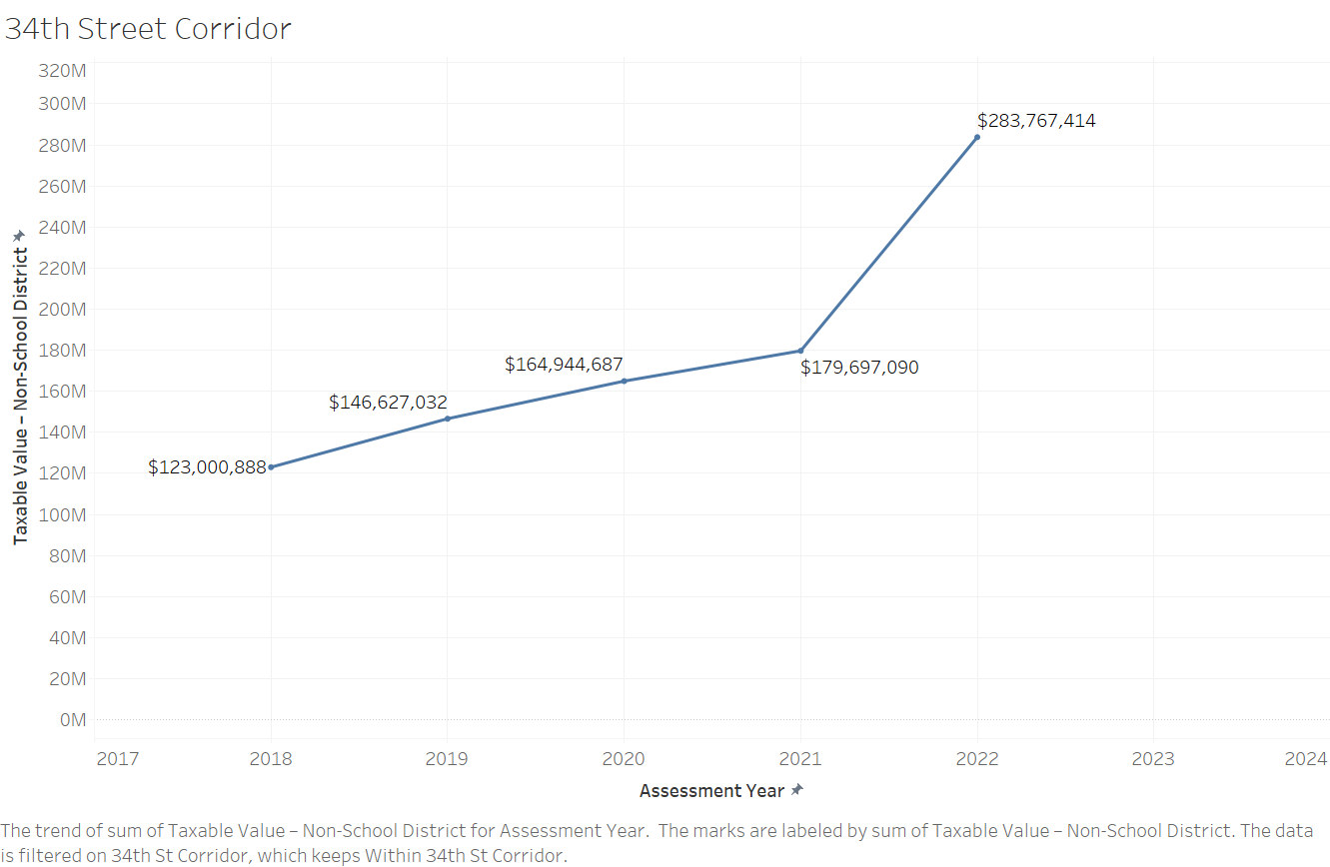

Figure 1: Line graph of total non-school district taxable value of properties for 34th Street corridor, shown annually.

See the appendix for the rest of the line charts to address this question, where there is one line chart created for every corridor of interest. As figure 1 shows, the line chart addresses the total non-school district taxable values of properties each year, and all charts show an increase for this value. Some corridors present significantly more of an increase in value than others. Looking at values alone (for the percent change over each year is analyzed in question C), the 34th street corridor multiplied its non-school district taxable values of properties by nearly 2.5 times, and there was a significant jump from the values in 2021 to 2022. Some other important finds in the other 7-line charts, located for reference in the appendix, are the following:

-The 16th street corridor, while maintaining only a slow increase from 2018 to 2021, had a large jump in the non-school district taxable values of properties from 2021 to 2022 (from about 4 million to 5 million dollars).

-The 18th street corridor had small but steady increases in taxable values over the years.

-The 22nd street corridor had moderate increases every other year (from 2019 to 2020, and from 2021 to 2022)

-The 49th street corridor had its largest increase from 2021 to 2022.

-The 5th street corridor experienced a large growth that increased in its growth rate each year from 2019 to 2022 (each year had a larger change than the last, excluding the larger change between 2018 and 2019). The non-school district taxable values of properties had more than doubled between 2018 and 2022.

-The Central Avenue corridor had a very steady and moderate increase in the non-school district taxable values of properties each year but had a significant increase from 2021 to 2022. These values also nearly doubled when comparing them from 2018 to 2022.

-The Dr. MLK Jr. St. corridor maintained truly little growth before having a significant increase between 2020 and 2021, then had moderate growth from 2021 to 2022.

Question B: “How have non-school district taxable values of properties across ALL commercial corridors in the CRA changed over time since 2018? Shown annually.”

To answer question B, a singular line graph was created, with each point on the graph representing the total non-school district taxable values of properties across all the corridors of interest in the CRA for a single year, as there was a point representing each year’s value from 2018 to 2022. See the image below for the line graph created to visualize this question.

Figure 2: Line Graph of non-school district taxable value of properties for all corridors of interest, shown annually.

When analyzing figure 2, the non-school district taxable value of properties for all corridors increased in small but extremely consistent and predictable intervals from 2018 to 2021. However, there was a significant increase in this value for all corridors between 2021 and 2022, where these taxable values jumped by about 140 million. The years before had an increase of about 40 million each year, so this is a substantial increase.

Question C: Visualization showing the “ranking” of corridors by change in non-school district taxable values. I.e., What corridors experienced the highest increases (percentage) in non-school district taxable values? What corridors experienced the lowest?

For question C, we created a column chart that shows the overall percent of change between 2018 and 2022 for each corridor’s sum of non-school district taxable values. The chart, shown below, is sorted so that an order of ranking is established for the percent of change for each corridor.

Figure 3: Column chart of the ranked percent difference of the sum of non-school district taxable values from 2018 to 2022.

Figure 3 shows that the 34th Street corridor has the largest percent increase in total non-school district taxable values from 2018 to 2022. The 5th Avenue corridor also had a large percent increase not far behind the 34th Street corridor. Central Avenue, 22nd Street, and Dr. MLK Jr. Drive all had good percentages of increase that were similar to one another. 16th Street, 49th Street and 18th Street all had lower percentages of change, with the 18th Street corridor having the lowest percent change at only a 23 percent increase in total non-school district taxable values from 2018 to 2022. However, it is important to note that there were no decreases in taxable value, and every corridor did have an increase in value over the years.

# Results

Question A: “How have non-school district taxable values of properties changed since 2018 on each of the commercial corridors? Shown annually.”

The non-school district taxable value of properties on each commercial corridor was analyzed and observed. The 34th Street corridor has the highest non-school district taxable value increase since 2018, with an increase of approximately 161 million dollars over the five years (multiplying its original value in 2018 by nearly 2.5 times). 104 million dollars of the total 161-million-dollar increase came from 2022 alone.

The Central Avenue corridor also had a large taxable value increase of 99 million dollars from 2018 to 2022, nearly doubling its original values in 2018. The corridor had steady and moderate increases from 2018 to 2021, and a significant increase in 2022.

The Dr MLK Jr corridor increased its non-school district taxable value of properties by 23 million dollars from 2018 to 2022, which is a moderate increase. However, the Dr. MLK Jr. St. corridor maintained truly little growth before having a significant increase between 2020 and 2021, then had moderate growth from 2021 to 2022.

Both the 22nd Street corridor and the 5th Avenue corridor had an $8 million increase of total non-school district taxable values from 2018 to 2022. The 22nd street corridor had moderate increases every other year, and the while the change in the taxable values seems smaller than other corridors, the 5th street corridor more than doubled its original 2018 value by 2022.

The 18th Street corridor, and the 49th Street corridor had total non-school district taxable value increases of 5 million and 4 million, respectively, from 2018 to 2022. The 18th Street corridor saw continual and steady increases, while the 49th Street corridor had a larger increase in 2022.

The 16th street corridor increased in total non-school district taxable values by the smallest value of $2 million, but also had the lowest value to begin with, so the increase was a moderate one and not as small as the others when comparing percent increases.

Question B: “How have non-school district taxable values of properties across ALL commercial corridors in the CRA changed over time since 2018? Shown annually.”

The non-school district taxable value of properties across all commercial corridors in the CRA has changed drastically from $290 million to $568 million and it depicts that the change has been almost doubled since 2018. Most of the change happened in the year 2021 to 2022, increasing from $426 million to $568 million, approximately a $140 million increase, when every year before was only seeing a steady increase of approximately $40 million.

Question C: Visualization showing the “ranking” of corridors by change in non-school district taxable values. I.e., What corridors experienced the highest increases (percentage) in non-school district taxable values? What corridors experienced the lowest?

By visualizing the data using a ranking style by a change in non-school district taxable values since 2018, the 34th Street Corridor ranks high with a 132% increase, followed by 5th Avenue with an increase of 111%. Both these corridors have the highest change in the taxable values and are therefore ranked the highest. A percent change of more than 100% indicates that the non-school district taxable values have more than doubled.

Central Avenue, 22nd Street, and Dr. MLK Jr. Drive all had good percentages of increase that were similar to one another, with more than 70% change from 2018 to 2022. These corridors did not rank the highest or the lowest for the percent increase of non-school district taxable values.

16th Street, 49th Street and 18th Street all had lower percentages of change, with the 18th Street corridor having the lowest percent change (and therefore ranking the lowest) at only a 23% increase in total non-school district taxable values from 2018 to 2022. However, all corridors did not decrease their total taxable values, and only saw an increase in this field over time.

# Conclusions

Analyzing the non-school district taxable value of properties across corridors of interest, both individually and altogether, allowed findings to be used by the city for the replication or replacement of strategies used across these corridors for the future.

The 34th Street corridor had moderate increases over time and a large increase in 2022 for non-school district taxable values (it also had the largest percent increase of this value from 2018 to 2022, at 132%), so the strategies used for this corridor should be analyzed and replicated in other similar corridors in the future. The 5th Avenue corridor also had a large percent increase (111%) of non-school district taxable values over the years, so the CRA should also analyze and repeat the strategies for this corridor as well to increase taxable values for other similar corridors.

The 18th Street corridor had the smallest percentile increase for non-school district taxable values from 2018 to 2022, so the strategies in this corridor should be analyzed and reworked for higher future increases. The techniques used in the 16th Street corridor should also be examined and revised to achieve greater future gains because this corridor saw the lowest numerical growth for non-school district taxable values over time.

Across all corridors, 2022 saw significant gains in non-school district taxable values, so factors that affect this value should be analyzed. If the main cause for the changes was something within the city’s control, such as a strategy used, these plans should be enacted in the future.

With interesting findings being found across the different corridors of interest for the city regarding non-school district taxable values, the strategies used in these corridors can now be analyzed and compared to each other to determine the best plan of action for future investments and projects for the city.

# Link to Visualizations

**Question A**

**Annual Changes in Non-School District Taxable Property Values for Individual Commercial Corridors**

[Dr Mlk Jr St Corridor](https://public.tableau.com/app/profile/claudio.moncada/viz/group7ism6155nontaxquestionaDrMLKJr/drmlkjrnontaxyearly?publish=yes)

[16th Street Corridor](https://public.tableau.com/app/profile/claudio.moncada/viz/group7ism6155nontaxQuestionA/16thnontaxyearly?publish=yes)

[18th Street Corridor](https://public.tableau.com/app/profile/claudio.moncada/viz/group7ism6155nontaxQuestionA/18thnontaxyearly?publish=yes)

[22nd Street Corridor](https://public.tableau.com/app/profile/claudio.moncada/viz/group7ism6155nontaxquestiona22ndSt/22ndnontaxyearly?publish=yes)

[49th Street Corridor](https://public.tableau.com/app/profile/claudio.moncada/viz/group7ism6155nontaxquestiona49thst/49thnontaxyearly?publish=yes)

[34th Street Corridor](https://public.tableau.com/app/profile/claudio.moncada/viz/group7ism6155nontaxquestiona34thSt/34thnontaxyearly?publish=yes)

[Central St Corridor](https://public.tableau.com/app/profile/claudio.moncada/viz/group7ism6155nontaxquestionaCentralSt/centralnontaxyearly?publish=yes)

[5th Street Corridor](https://public.tableau.com/app/profile/claudio.moncada/viz/group7ism6155nontaxquestiona5thst/5thnontaxyearly?publish=yes)

**Question B**

**Annual Changes In Non-School District Taxable Property Values Across All Commercial Corridors in the CRA Since 2018:**

[Question B Group 7 Graph](https://public.tableau.com/app/profile/claudio.moncada/viz/group7ism6155QuestionB/withinCRAinterest?publish=yes)

**Question C**

**Ranking Of Commercial Corridors By Percentage Change of Non-School District Taxable Property Values from 2018 to 2022**

[Question C Group 7 Graph Analysis](https://public.tableau.com/app/profile/claudio.moncada/viz/Percentdifferenceofthesumoftaxablevaluesbetween2018and2022QuestionCGroup7/CRAChangeDuringyears20182022?publish=yes)

# Appendix

**Visualizations for the Annual Changes in Non-School District Taxable Property Values for Individual Commercial Corridors (All Graphs for Question A)**

